FAQ for Thesis Upload Instructions
Jun. 16, 2017
〈Security Settings〉
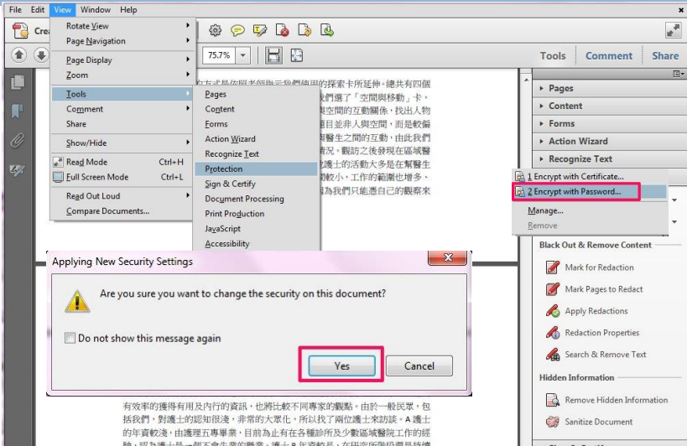

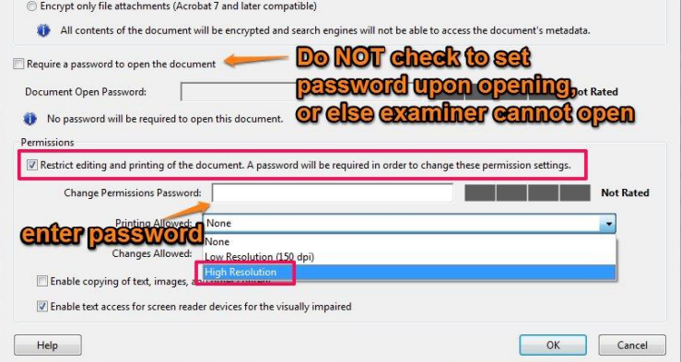
- For both full text and abstract PDF files, please set the security and change the printing allowed.
View Tools Protection Encrypt Encrypt with Password t On Permissions block, check “Restrict editing and printing of the document. A password will be required in order to change the permission settings.” Enter the password Change printing allowed into High Resolution.

〈Others〉
- Please remember to add your student ID on the front cover.

