清華大學資訊系統與應用研究所學位論文延後公開申請書
Application for Embargo of Thesis/ Dissertation
申請人姓名  Applicant’s Name |  | 學位類別  Graduate Degree | □碩士Master | 畢業年月  Graduation Date  (YYYY/MM) | 民國 年 月  /
學校名稱  University |  |  | 系所名稱  School/Department
論文名稱
Thesis /
Dissertation Title
延後公開原因*  Reason for Delayed Display | ☐涉及機密  Contains information pertaining to the trade secret.  ☐專利事項，申請案號：  Filing for patent registration. Patent filing number:  ☐依法不得提供，請說明：  Withheld according to the law. Please specify. |  |  | 公開日期  Delayed Until  (YYYY/MM/DD) | 民國 年 月 日  / /
申請項目  Options | - 紙本論文延後公開  Delay public access to the printed copies of my thesis, but leave the online bibliographic record open to the public.  - 書目資料延後公開  Delay public access to online bibliographic record of my thesis. |  |  | 公開日期  Delayed Until  (YYYY/MM/DD) | 民國 年 月 日  / /
檢附文件或延後公開原因說明
Attachment or Description for Delayed Display

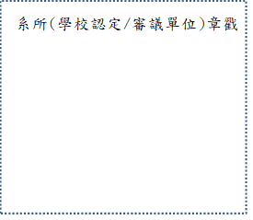
申 請 人： ___________________（簽名）

指 導 教 授： ___________________（簽名）

